CHEMISTRY PRACTICE TEST
Mixed Topics — Practice Test 02
Test Name | Mixed Topics — Practice Test 02
Exam | JEE Main
Topics | Atomic Structure, Chemical Bonding, Thermodynamics,  Periodic Table, Equilibrium, Electrochemistry, Organic Chemistry
Difficulty | Medium
Total Questions | 20 (SCQ: 5 | MCQ: 5 | Integer Type: 5 | Match The Column: 5)

INSTRUCTIONS

1. This paper contains 20 questions divided into 4 sections.
2. SCQ — Only ONE option is correct.
3. MCQ — One or more options may be correct.
4. Integer Type — Answer is a non-negative integer.
5. Match The Column — Match each item in Column A with one in Column B.
6. Some questions have diagrams in the question, as options, or in the solution.
7. Correct Answer and Solution follow every question.

SECTION I: Single Choice Questions (SCQ)
Only one option is correct. | Exam: JEE Main | Topics: Atomic Structure, Bonding, Thermodynamics, Periodic Table, Equilibrium
1. The electronic configuration of Cu (Z = 29) is:
Topic: Atomic Structure
(1) [Ar] 3d⁹ 4s²
(2) [Ar] 3d¹⁰ 4s¹
(3) [Ar] 3d⁸ 4s²
(4) [Ar] 3d¹⁰ 4s²

Answer: (2) [Ar] 3d¹⁰ 4s¹
Solution:
Cu has an anomalous configuration. A fully filled 3d¹⁰ subshell gives extra stability.
Expected: [Ar] 3d⁹ 4s². Actual: [Ar] 3d¹⁰ 4s¹ (one electron shifts from 4s to 3d).

2. Which of the following diagrams correctly represents the shape of an H₂O molecule? (Refer to the diagrams below.)
Topic: Chemical Bonding
(1) Linear
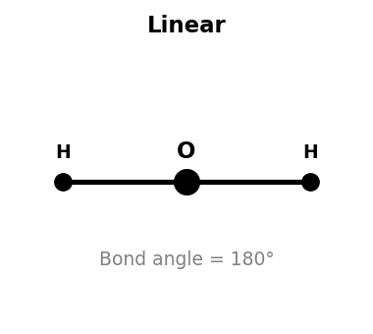

(2) Bent (V-shape)
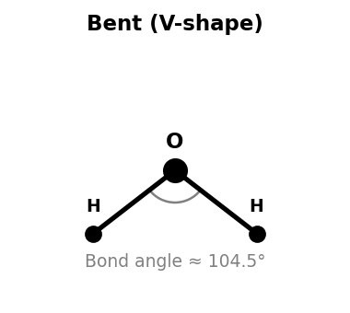

(3) Trigonal Planar
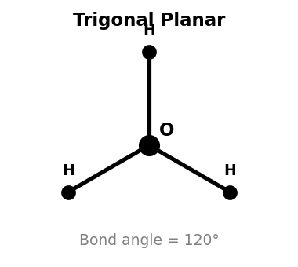

(4) Tetrahedral
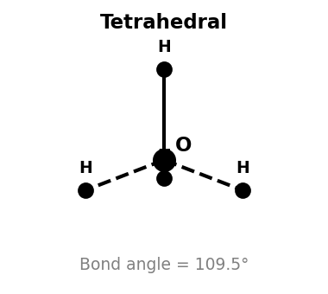

Answer: (2) Bent (V-shape)
Solution:
O in H₂O: 2 bonding pairs + 2 lone pairs → sp³ hybridisation.
Electron geometry: tetrahedral. Molecular shape: bent.
Bond angle ≈ 104.5° (reduced from 109.5° due to lone pair repulsion).
Diagram (1) is linear (e.g. CO₂), (3) is trigonal planar (e.g. BF₃), (4) is tetrahedral (e.g. CH₄).

3. For a reaction: ΔH = −30 kJ/mol, ΔS = −100 J/mol·K. The reaction is spontaneous:
Topic: Thermodynamics
(1) At all temperatures
(2) At no temperature
(3) Only at temperatures below 300 K
(4) Only at temperatures above 300 K

Answer: (3) Only at temperatures below 300 K
Solution:
ΔG = ΔH − TΔS = −30000 − T(−100) = −30000 + 100T
For spontaneity: ΔG < 0 ⇒ −30000 + 100T < 0 ⇒ T < 300 K.
At T = 300 K: ΔG = 0 (equilibrium). Above 300 K: ΔG > 0 (non-spontaneous).

4. Which of the following has the SMALLEST atomic radius?
Topic: Periodic Table
(1) Na
(2) Mg
(3) Al
(4) Si

Answer: (4) Si
Solution:
Across Period 3 (left to right): nuclear charge increases, atomic radius decreases.
Order: Na > Mg > Al > Si.
∴ Si (Z = 14) has the smallest radius among the four.

5. The graph below shows the titration curve of 25 mL of 0.1 M HCl with 0.1 M NaOH. The volume of NaOH required to reach the equivalence point is:
Topic: Equilibrium
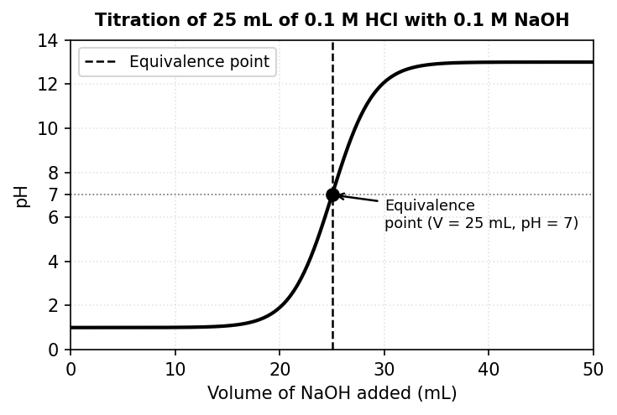
(1) 10 mL
(2) 25 mL
(3) 40 mL
(4) 50 mL

Answer: (2) 25 mL
Solution:
Moles of HCl = 0.025 L × 0.1 mol/L = 0.0025 mol.
At equivalence: moles NaOH = moles HCl = 0.0025 mol.
Volume NaOH = 0.0025 / 0.1 = 0.025 L = 25 mL.
This matches the steep rise at 25 mL on the graph.

SECTION II: Multiple Choice Questions (MCQ)
One or more options may be correct. | Exam: JEE Main | Topics: Bonding, Equilibrium, Atomic Structure, Electrochemistry, Organic
6. Which of the following statements about ionic bonds are CORRECT?
Topic: Chemical Bonding
(1) Ionic bonds form between metals and non-metals by electron transfer
(2) Ionic compounds conduct electricity in the molten state
(3) NaCl has a coordination number of 6 in its crystal structure
(4) Ionic bonds have fixed directionality like covalent bonds

Answer: (1), (2) and (3)
Solution:
(1) ✓ Ionic bonds arise from metal → non-metal electron transfer.
(2) ✓ Molten ionic compounds have mobile ions → good electrical conductors.
(3) ✓ In the NaCl crystal each Na⁺ is surrounded by 6 Cl⁻ ions (and vice versa).
(4) ✗ Ionic bonds are non-directional (electrostatic in all directions).

7. For the equilibrium N₂(g) + 3H₂(g) ⇌ 2NH₃(g), ΔH = −92 kJ/mol. Which changes will INCREASE the yield of NH₃?
Topic: Equilibrium
(1) Increasing pressure
(2) Increasing temperature
(3) Removing NH₃ as it forms
(4) Adding a catalyst

Answer: (1) and (3)
Solution:
(1) ✓ Higher pressure shifts equilibrium toward fewer gas moles (4 → 2). Yield increases.
(2) ✗ Exothermic reaction → higher T shifts equilibrium left. Yield decreases.
(3) ✓ Removing product shifts equilibrium right (Le Chatelier’s principle).
(4) ✗ Catalyst speeds up rate but does NOT shift equilibrium. Yield unchanged.

8. Refer to the four orbital shapes shown in the diagram below. Which of them correctly represent atomic orbitals found in the second shell (n = 2)?
Topic: Atomic Structure
(1) Shape I only
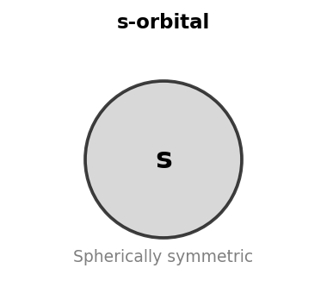

(2) Shapes I and II
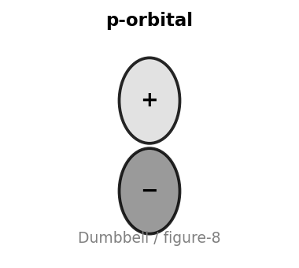

(3) Shapes I, II and III
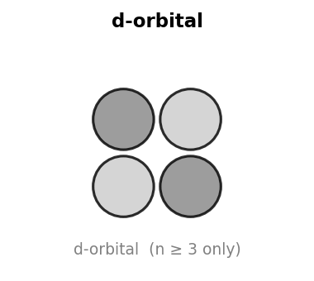

(4) All four shapes
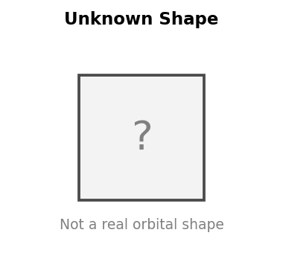

Answer: (2) Shapes I and II
Solution:
The second shell (n = 2) contains: 2s (one orbital) and 2p (three orbitals).
Shape I (sphere) ✓ correctly represents an s-orbital.
Shape II (dumbbell) ✓ correctly represents a p-orbital.
Shape III (4-lobe clover) ✗ represents a d-orbital — only from n = 3 onwards.
Shape IV (square) ✗ is not a real atomic orbital shape.

9. Which of the following statements about the Standard Hydrogen Electrode (SHE) are CORRECT?
Topic: Electrochemistry
(1) Its standard reduction potential is 0.00 V by convention
(2) H₂ gas is supplied at 1 atm pressure
(3) The solution contains H⁺ at 1 M concentration
(4) SHE always acts as the anode in an electrochemical cell

Answer: (1), (2) and (3)
Solution:
(1) ✓ E°(SHE) = 0.00 V by international convention.
(2) ✓ H₂ is bubbled at exactly 1 atm (standard conditions).
(3) ✓ [H⁺] = 1 M (pH = 0).
(4) ✗ SHE can act as anode OR cathode depending on the other half-cell.

10. Which of the following are characteristic features of SN2 reactions?
Topic: Organic Chemistry
(1) Inversion of configuration at the reaction centre (Walden inversion)
(2) First-order kinetics: rate = k[substrate]
(3) Favoured by primary alkyl halides
(4) Proceeds via a planar carbocation intermediate

Answer: (1) and (3)
Solution:
(1) ✓ SN2 proceeds by backside attack → configuration inverts (Walden inversion).
(2) ✗ SN2 is second-order: rate = k[substrate][nucleophile]. Not first-order.
(3) ✓ Primary substrates have less steric hindrance → backside attack is easier.
(4) ✗ Carbocation intermediate is SN1, not SN2. SN2 is concerted (no intermediate).

SECTION III: Integer Type Questions
Answer is a non-negative integer. | Exam: JEE Main | Topics: Redox, Bonding, Solutions, Electrochemistry, Organic
11. The oxidation number of Cr in K₂Cr₂O₇ is _____.
Topic: Redox Chemistry
Answer: 6
Solution:
Let oxidation state of Cr = x.
2(+1) + 2x + 7(−2) = 0
2 + 2x − 14 = 0 ⇒ 2x = 12 ⇒ x = +6.

12. The number of σ (sigma) bonds in ethyne (HC≡CH) is _____.
Topic: Chemical Bonding
Answer: 3
Solution:
H–C: 1 σ bond
C≡C: 1 σ bond + 2 π bonds
C–H: 1 σ bond
Total σ bonds = 1 + 1 + 1 = 3.

13. The van't Hoff factor (i) for Na₂SO₄ assuming complete dissociation is _____.
Topic: Solutions
Answer: 3
Solution:
Na₂SO₄ → 2Na⁺ + SO₄²⁻
Total ions produced per formula unit = 2 + 1 = 3.
∴ i = 3.

14. The diagram shows a Zn–Cu galvanic cell. If 65 g of Zn (molar mass = 65 g/mol) is completely consumed at the anode, the total moles of electrons transferred through the external circuit is _____.
Topic: Electrochemistry
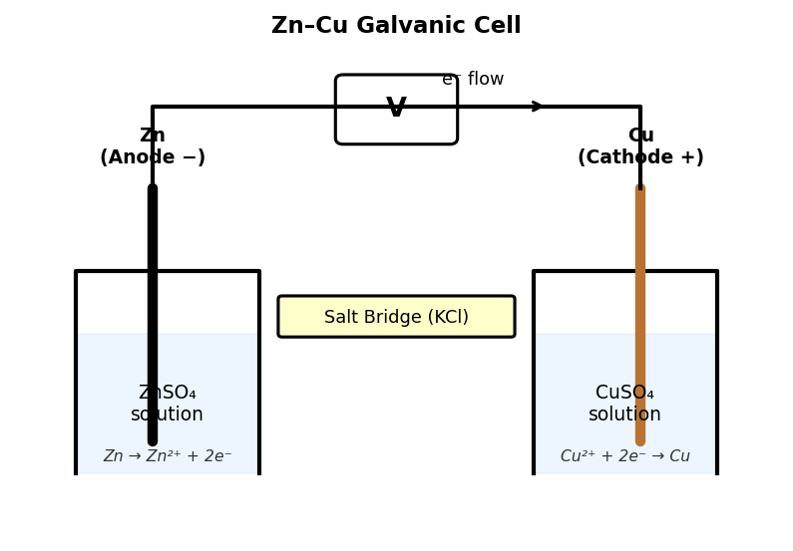
Answer: 2
Solution:
At anode (oxidation): Zn → Zn²⁺ + 2e⁻
Moles of Zn = 65 ÷ 65 = 1 mol.
Each mole of Zn releases 2 moles of electrons.
∴ Moles of electrons = 1 × 2 = 2.

15. The number of structural isomers of molecular formula C₄H₁₀ is _____.
Topic: Organic Chemistry
Answer: 2
Solution:
C₄H₁₀ has two possible carbon skeletons:
(1) n-Butane: CH₃–CH₂–CH₂–CH₃ (straight chain)
(2) Isobutane (2-Methylpropane): (CH₃)₃CH (branched)
No other structural arrangements are possible for C₄H₁₀.
The structural diagrams of both isomers are shown below:
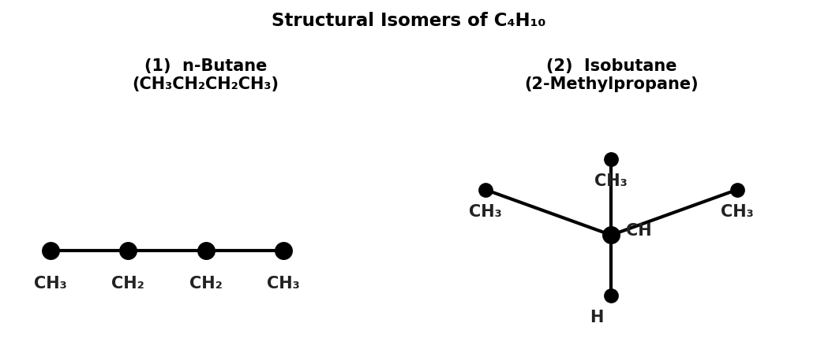

SECTION IV: Match The Column
Match each item in Column A with the correct item in Column B. | Exam: JEE Main | Topics: Bonding, Organic, Periodic Table, Thermodynamics
16. Match each molecule in Column A with its correct hybridisation in Column B.
Topic: Chemical Bonding
Column A | Column B
(A) CH₄ | (P) sp
(B) BF₃ | (Q) sp²
(C) H₂O | (R) sp³
(D) C₂H₂ (ethyne) | (S) sp³ with 2 lone pairs

Answer: A – R, B – Q, C – S, D – P
Solution:
CH₄ : 4 bonding pairs, no LP → sp³ → A – R
BF₃ : 3 bonding pairs, no LP → sp² → B – Q
H₂O : 2 bonding + 2 lone pairs → sp³ (2 LP) → C – S
C₂H₂ : triple bond, linear → sp → D – P

17. Match each organic reaction in Column A with its correct reaction type in Column B.
Topic: Organic Chemistry
Column A | Column B
(A) CH₄ + Cl₂ → CH₃Cl + HCl (light) | (P) Electrophilic substitution
(B) CH₂=CH₂ + H₂ → CH₃CH₃ (Ni) | (Q) Nucleophilic substitution
(C) C₂H₅OH + HBr → C₂H₅Br + H₂O | (R) Free radical substitution
(D) C₆H₆ + Br₂ → C₆H₅Br + HBr (FeBr₃) | (S) Addition

Answer: A – R, B – S, C – Q, D – P
Solution:
CH₄ + Cl₂ (light): free radical chain mechanism → A – R
Alkene + H₂ (Ni): addition across double bond → B – S
Alcohol + HBr: OH replaced by Br⁻ (nucleophile) → C – Q
Benzene + Br₂ (FeBr₃): electrophilic aromatic sub. → D – P

18. Match each property in Column A with the correct element in Column B.
Topic: Periodic Table
Column A | Column B
(A) Most electronegative element | (P) H
(B) Element with anomalously high IE due to half-filled 2p³ | (Q) Li
(C) Largest atomic radius in Period 2 | (R) N
(D) Smallest non-metallic element | (S) F

Answer: A – S, B – R, C – Q, D – P
Solution:
Most electronegative = F (Pauling scale: 4.0) → A – S
High IE due to half-filled 2p³ (N: 1s² 2s² 2p³) → B – R
Largest radius in Period 2 = Li (leftmost, least Z) → C – Q
Smallest non-metallic element = H (lightest non-metal) → D – P

19. Match each molecule in Column A with its correct molecular shape in Column B.
Topic: Chemical Bonding
Column A | Column B
(A) H₂O | (P) Linear
(B) NH₃ | (Q) Trigonal planar
(C) BF₃ | (R) Trigonal pyramidal
(D) CO₂ | (S) Bent

Answer: A – S, B – R, C – Q, D – P
Solution:
H₂O : 2 BP + 2 LP → Bent (bond angle ≈ 104.5°) → A – S
NH₃ : 3 BP + 1 LP → Trigonal pyramidal (≈ 107°) → B – R
BF₃ : 3 BP + 0 LP → Trigonal planar (120°) → C – Q
CO₂ : 2 double bonds, no LP → Linear (180°) → D – P

20. Match each term in Column A with its correct description as seen on an energy profile diagram in Column B.
Topic: Thermodynamics
Column A | Column B
(A) Activation energy (Eₐ) | (P) Lowers Eₐ without changing ΔH
(B) ΔH of reaction | (Q) Highest energy point on the curve
(C) Transition state | (R) Energy gap between products and reactants
(D) Effect of a catalyst | (S) Minimum energy barrier for reaction

Answer: A – S, B – R, C – Q, D – P
Solution:
Eₐ = minimum energy needed to start the reaction → A – S
ΔH = E(products) − E(reactants) on the profile → B – R
Transition state = peak (highest energy point) → C – Q
Catalyst lowers Eₐ, ΔH stays the same → D – P
Refer to the annotated energy profile diagram below:
